Reno Region’s Awards Banquet
͞͞͞— and —
End of Year Celebration

Event Date: Saturday, December 14,2024

Host Venue: Casino Fandango
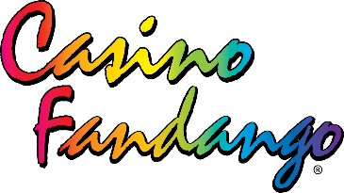
3800 S. Carson St (Hwy 395)
Carson City, NV 89423
In the Room behind the Craft 55 Bar
Event Time: 4:00 – 5:00 pm Regional Annual Meeting
5:00 – 6:00 pm Cocktails (No Host Bar)
6:00 – 9:00 pm Dinner Buffet/Awards

Please join us, Reno Region of SCCA, in celebrating our 57th Anniversary and the End of Year Award! Prior to the celebration and award ceremony, we will have a Regional Annual Meeting to recap 2024, elect the new 2025 Board of Directors and preview 2025 season! Missed the voting period? Don’t worry! Write-in nominations and votes can be submitted during the Regional Annual Meeting, before the dinner and Awards.

Do you have any past Regional memorabilia, past event items, or autosport-related-items that you would want to donate as a raffle item? If you do, bring it with you to the check-in table! Event t-shirts, past and or present photos, including the stories to go with, stickers, toy cars, blankets, etc. Always great to bench race!

Dinner Buffet where you can pick between three entrees, salad, potatoes, veggies, rolls & desserts. Cost for the dinner buffet is $50.00 per-person Adult; $20.00 per-person Youth 3-12 yrs.
Register online @ msreg.com/awards24-renoscca

